Unit 1.4 Graded Assignment

Name: Hamza Mohammad Asim
Employee #: 2303.KHI.DEG.014
Collaborated with: Saad Sameer Khan (2303.KHI.DEG.034)

- Creating Dockerfile:
- First we made a directory ‘Unit 1.4’ for this assignment and created a Dockerfile there.
- Next, we wrote our Dockerfile:

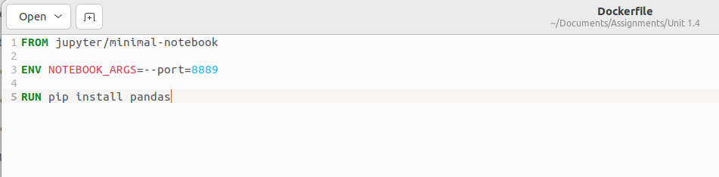

- Here,
-FROM: specifies what base image we want for the image that we are building. In this case, its Jupyter Minimal Notebook.
-ENV: sets the environment variables for our image. In this case we’re setting the default ports our jupyter notebook should have, 8889.
-RUN: specifies what commands are going to run when starting this image in a container. In this case we want pandas to be installed in our image, so we write ‘pip install pandas’

- Building Dockerfile:
- We build our dockerfile by changing directory to the folder we’ve created the Dockerfile in, in our case ‘Unit 1.4’.
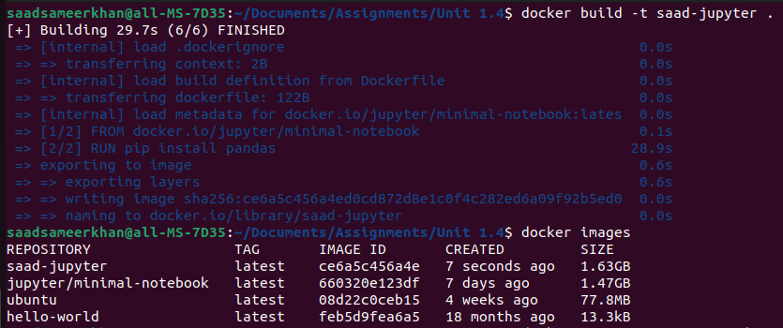
- Here, with ‘-t’ we give a name to our image. ‘saad-jupyter’ and ‘.’ specifies the location of our dockerfile, which is where our current directory is so ‘.’
- Running our image:
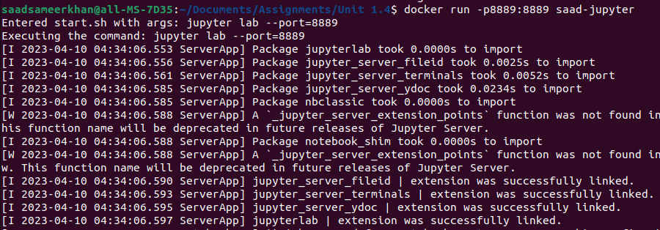
Here, with -p we bind the Host’s ports with the container’s ports.

- Running our image:
Now to verify whether our container is running we open the link:
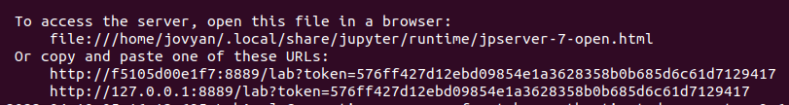
It works:
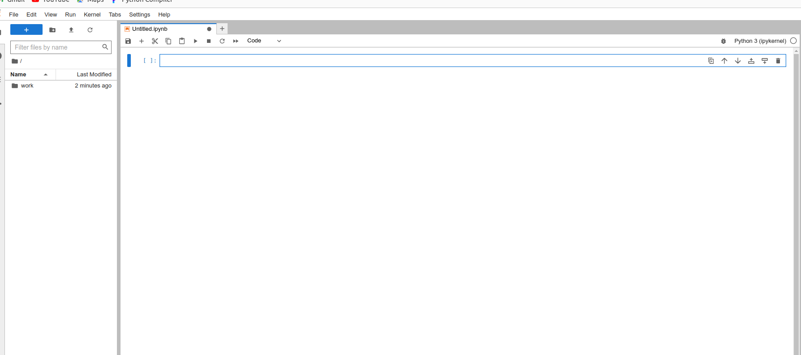
Now Run pandas, to see if it was installed:
